Procedure to Install MSSQL Server 2014

PURPOSE:-
The purpose of this document is to provide details on how Support team will create Rebuild and Reorg jobs created by using maintenance plan.

Rebuild Index Task (Maintenance Plan)

- Open up SQL Server Management Studio
- Expand out Management
- Right Click on Maintenance Plans
- Choose Maintenance Plan Wizard
- 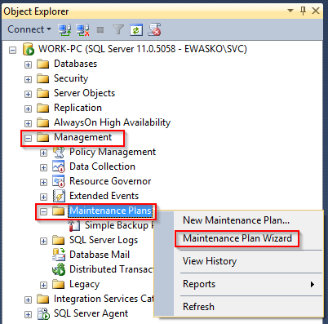
- Name your plan something you can remember what it does "Rebuild Indexes on the fly" for example.
- Click Next
- Check "Rebuild Index" and "Update Statistics"
- 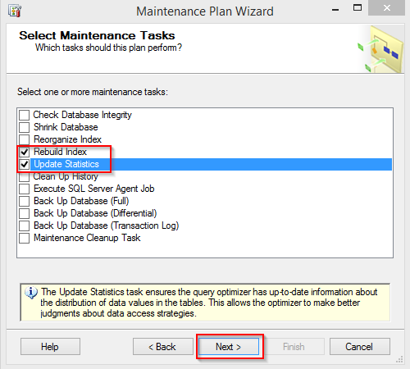
- Click Next
- Rebuild should be at the top
- Click Next
- Choose under Databases: All user databases
- Click Next
- Choose under Databases: All user databases
- Click Next
- Note or Change the location of the report of this task
- Click Next
- Click Finish
- Final screen upon successful creation 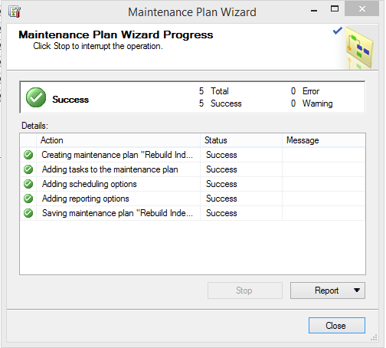
- Now you will have your task created under Maintenance Plans
- Right click on your maintenance plan, it will show the name you gave it in step 6
- Click Execute

